PRODUCT SPECIFICATION

Product Name： LED panel light

Product model： NS-WP01-20-PDSR-40K/ NS-WP01-20-PDSR-80K/

NS-WP01-24-PDSR-40K/ NS-WP01-24-PDSR-80K

DESCRIPTION ： LED surface panel light (SMD2835)



● Features

1. Using plastic integrated structure, good appearance, high class looking.
2. Built-in constant current driver, high efficiency, stability.
3. Using the imported SMD as light source, high light efficiency, long lifespan.
4. Quick response time, the LED response time is nanosecond.
5. Environmental protection, no heavy metals and harmful gas .
6. Energy-saving, can save energy more 80% than traditional lights.
7. . No flicker, start quickly, soft light, protect your eyes.
8. . Easy to install and use.

* Technical Parameter

|  |  |  |  |
| --- | --- | --- | --- |
| Model | 20W | | 24W |
| LED model | 2835 | | 2835 |
| LED Qty | 54 PCS | | 40 PCS |
| Power | 20 W | | 24 W |
| Voltage | AC110-240 V | | AC110-240 V |
| Working Frequency | | 50/60HZ | 50/60HZ |
| Power Efficiency | | ≥ 92% | ≥ 92% |
| Luminous Flux | | 2000LM | 2400LM |
| Luminousefficiency | | 105LM/W ±10% | |
| Power Factor | | ≥ 0.5 | |
| ColourTemperature | | NW: 3710-4260K WH: 7490-8510K | |
| CRI | | Ra ≥ 80 | |
| Bean Angle | | 120º | |
| WorkingTemperature | | -20 to + 5 0 ºC | |
| Service life | | 30,000hr life 3yr warranty | |

* Relative Spectral Energy Distribution

NS-WP01-20-PDSR-40K

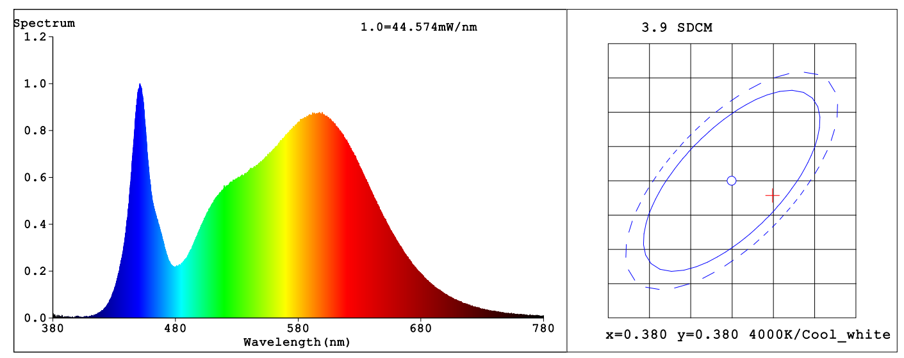

NS-WP01-24-PDSR-40K

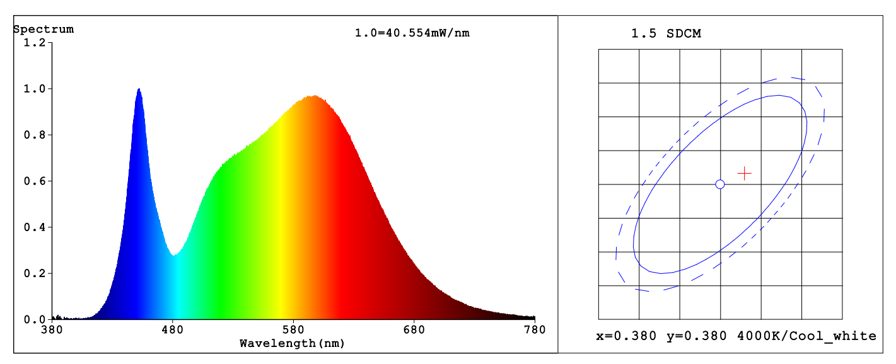

* Optical characteristic curve

NS-WP01-24-PDSR-40K

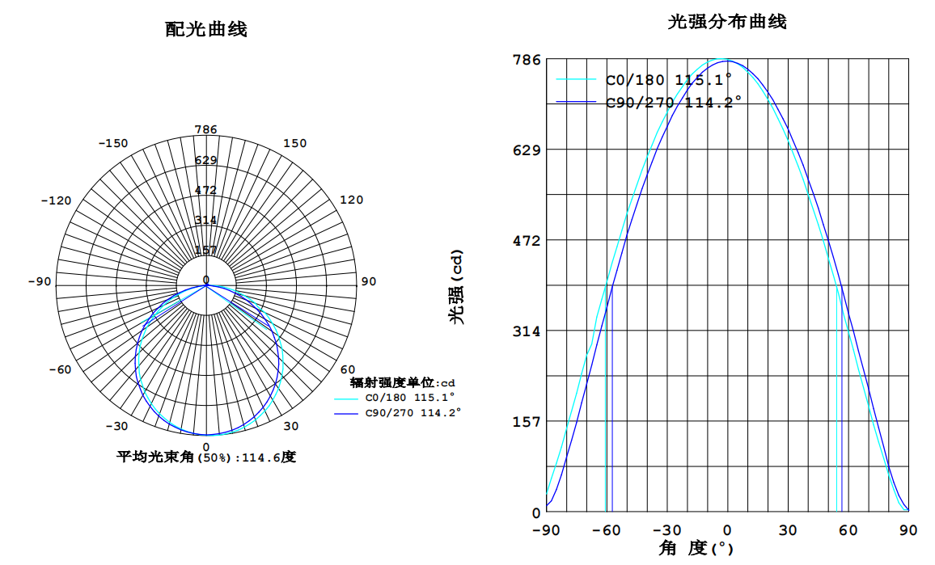

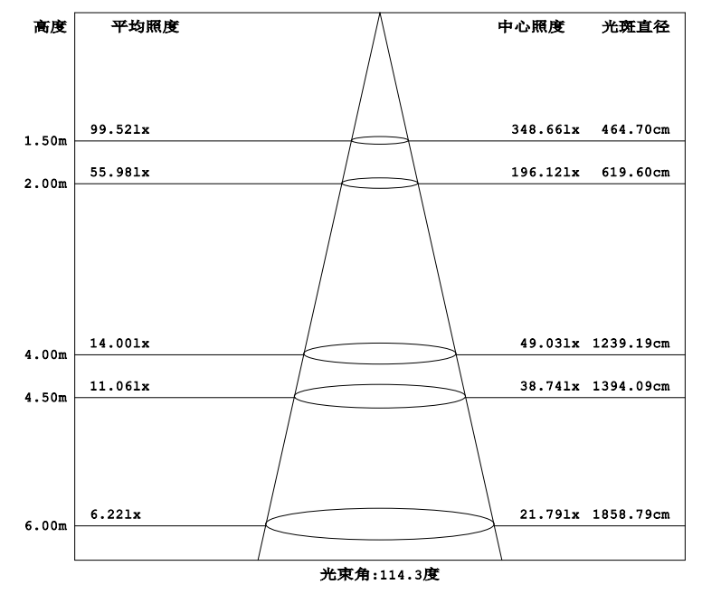

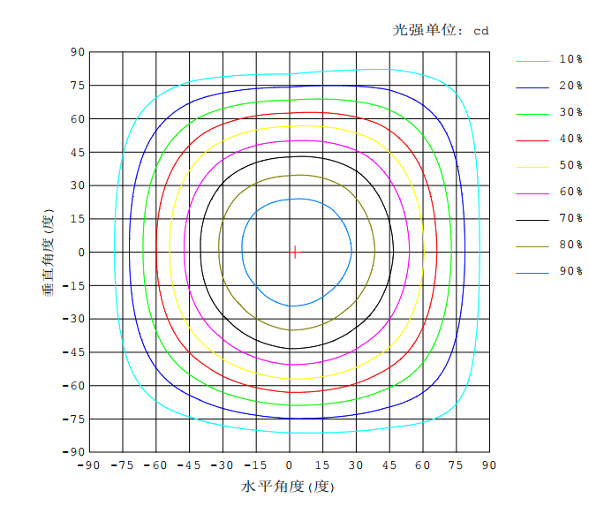

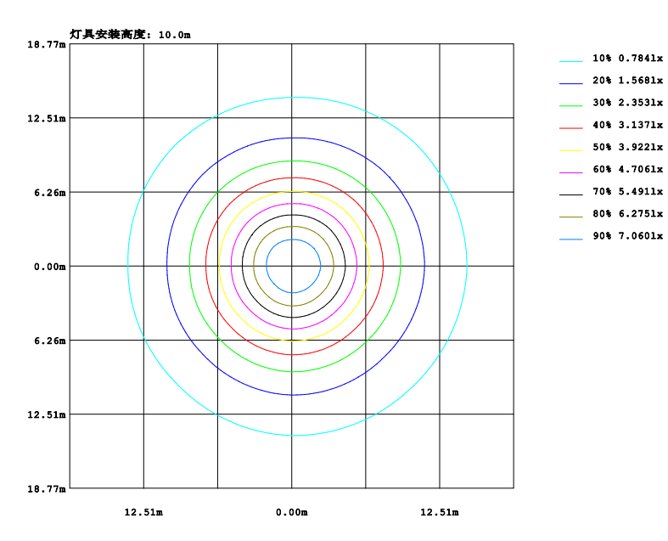

* Dimensions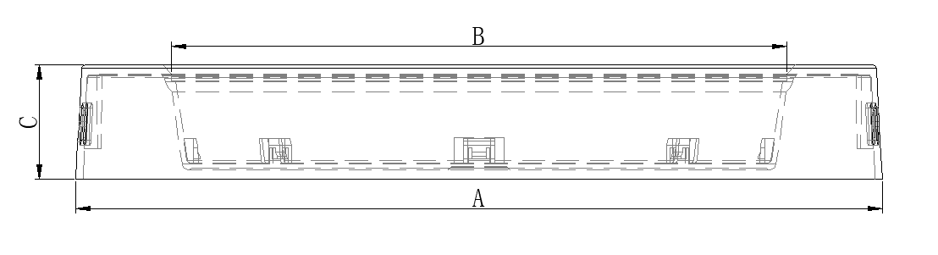Model Diameter (mm) A(mm) B(mm) C(mm)

|  |  |  |  |  |
| --- | --- | --- | --- | --- |
| 20W | / | 225± 1 | 172± 0.5 | 32± 0.5 |
| 24W | / | 290 ± 1 | 250 ± 0.5 | 32± 0.5 |
|  |  |  |  |  |

* Instruction of wiring

1. Diagram of power supply wiring ：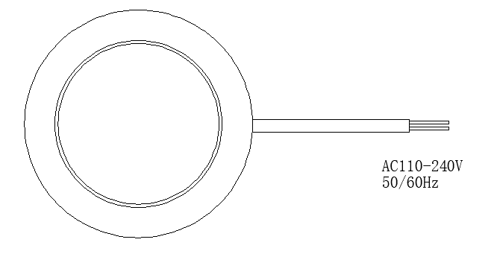

● Installation Instructions

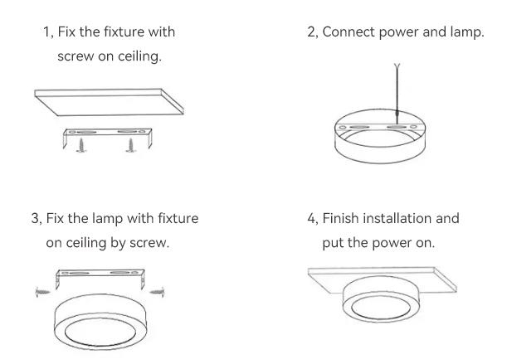

1. Fix the fixture with screw on ceiling;
2. Connect power and lamp;
3. Fix the lamp with fixture on ceiling by screw;
4. Finish installation and put the power on.

* Product Package

Packed in color box,40 PCS/ case

* Packing size & Pictures：

|  |  |  |  |
| --- | --- | --- | --- |
| Model | L (mm) | W (mm) | H (mm) |
| NS-WP01-20-PDSR-40K | 480 | 420 | 480 |
| NS-WP01-20-PDSR-80K | 480 | 420 | 480 |
| NS-WP01-24-PDSR-40K | 600 | 420 | 600 |
| NS-WP01-24-PDSR-80K | 600 | 420 | 600 |

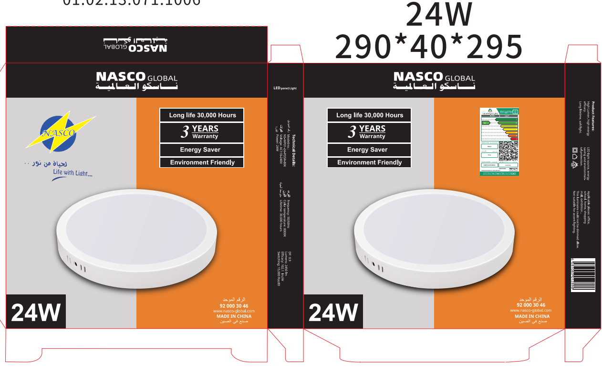

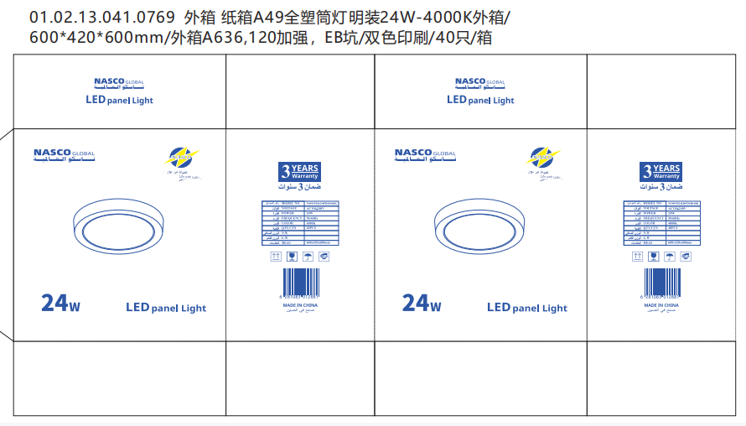

●Attentions

1. Make sure the power is off before maintenance.
2. Clean the glass of diffuser of lamp regularly to maintain good light transmittance.
3. Clean the dust of the shell to maintain good heat dissipation performance.
4. Be careful not to use water or corrosive solution for cleaning, it is better to use a dry cloth.

●Warranty and After-sales Service

The period of guarantee is 3 years. Quality assurance is based on the correct storage, installation, use and maintenance of products. Due to improper installation

and improper use of the product, the product is damaged beyond the scope of this warranty. During the warranty period, We will choose to repair, replace (spare parts)

with new products. Labor charges or material costs will be appropriately collected over the warranty period.

● Products Application Cases

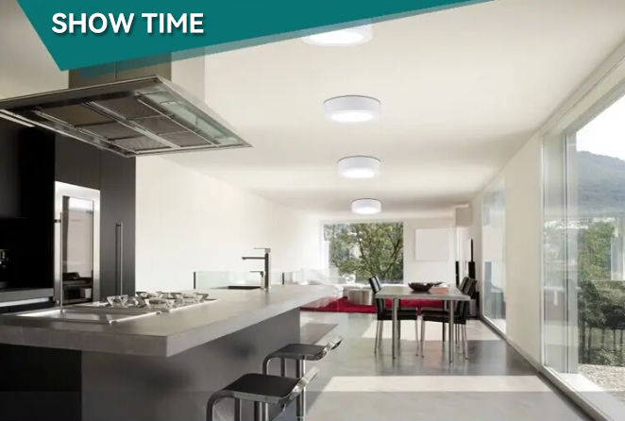

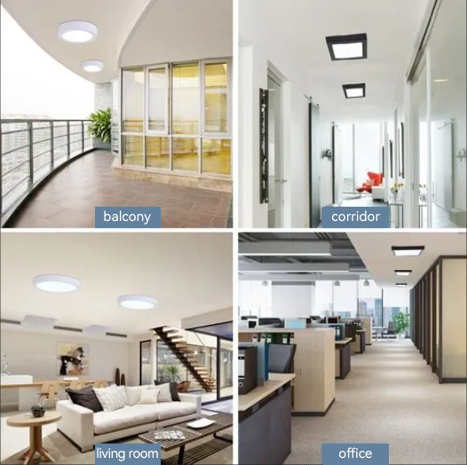

The date listed in this file is for reference only, and the specific date should be subject to the specific products, if any change, sorry for no notice.